House Warming Ritual

1. An auspicious date and time is chosen.

2. On the auspicious day and time, the owner of the home brings some auspicious items into the home:

PACKET OF SALT, RICE & SUGAR

2.1 A packet of salt, rice and sugar.

2.2 Other Items:-

CHARCOAL

- A red charcoal stove (Optional)
- A charcoal (representing gold) wrapped in Red paper. One can bring this in and need not light it up. But if one wants to light up, then do it before the auspicious time. And bring in the red charcoal stove into the house. In this option, the stove has to be kept permanently in the house e.g. kitchen cabinet and must not throw it away.(Optional)

An alternative is to light up the charcoal red-hot and when it is time, transfer the charcoal from the outside of the house to the kitchen stove-top.

- A `huat' quay or self-raising cake (symbolic of a `raise') & or longevity bread (apricot bread). See picture 1: below.

PINEAPPLE

- For the Hokkien (Chinese dialect group) purchase of a pineapple (with flower on it). Once the time is right, open the main entrance door and roll the pineapple from the main entrance door into the house. A `pineapple' here represent luck.

BOIL WATER & TURN ON ALL LIGHTS

Besides the above, water is boiled immediately after entering the home and all lights in the home are turned on for at least 15 mintures. If one is staying in the house, turn on the `balcony' light or if there is no balcony, the living room light for that night.

RED PACKETS

Red Hong Bao packets are also placed e.g. on the kitchen stove and keep a Red Hong Bao in each bedroom's cupboard drawer. The money should be even numbers. For example, it can be 6 cents. For the Hokkien, 6 sounds like luck. For the Cantonese, they may use 8 cents for luck.

Picture 1: Showing some of the items on the day of symbolic move:-

- A red container with charcoal (representing gold)
- A packet of sweets
- A `self-raising' cake or `Huat Quay'
- A pineapple with it's flower intact
- A red packet on top of charcoal wrapped in red paper on top of a red stove.

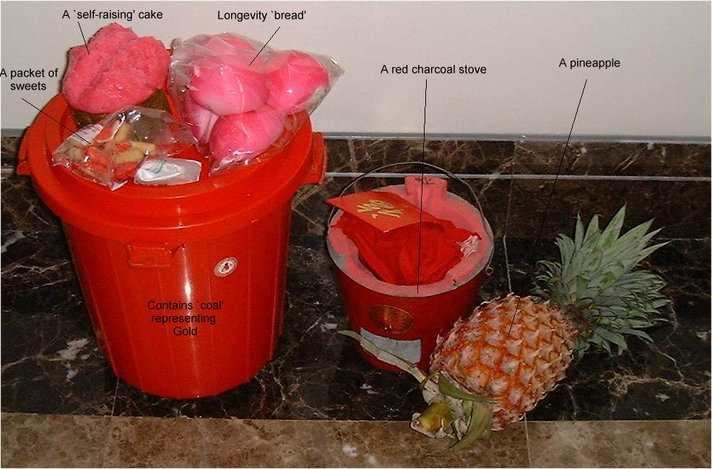

Picture 2: Close up picture of some of the items above

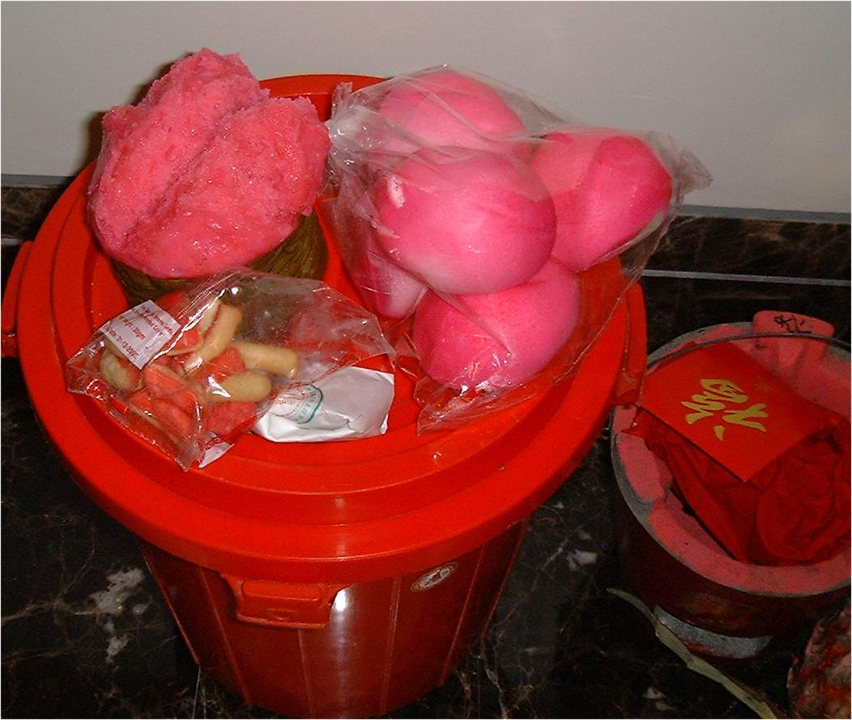

Picture 3: Boiling Water (symbolic of warmth in the kitchen)

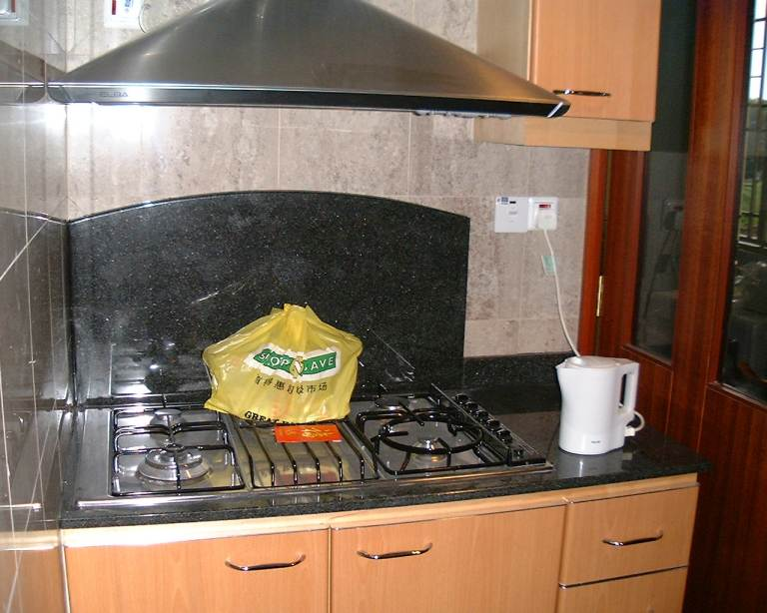

End

